LAB4 REPORT
Please find the images referred in this report in the folder images within the zip archive.

Task1
- SETUP
After lunching the apache Drill server using ./bin/drill-embedded from the installation directory, I then open the user interface from the browser using http://localhost:8087; I then started mongo server,imported the related files and enable the mongo plugin in apache drill interface.
- Import the structures egalite femmes hommes file in mongo:
Mongoimport -c structure –jsonArray –port 20217 ./filepath
- The query used is:
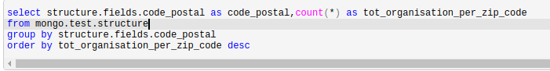
The related picture is task1_3.
NB: the command USE mongo.test allows to specify the default schema.
- As we can notice from the picture ,the organisation’s zip code data is not complete because we have some missing values substituted with “null” in particular 26 for the attribute code_postal.
- The query used to save data into a parquet file is:
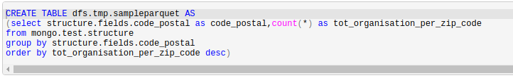
And the picture that shows the result is task1_5
- The query used to retrieve data from the parquet file is :
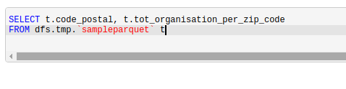
And the picture that shows the result is task1_6

Task2

- To import the Boston crime csv file in postgres, I first created a user named my_postgres, add him to the database and then I created a db named db with that user as owner. The commands are the following:
Sudo adduser my_posgres(create a new user)
Su – postgres (login as default posgres user)
Psql -> then we create the user user in the db, with a database with that user as owner.
In order to load the file, i first login as my_postgres and then i issue the following command:
- The plugin configuration for setting up the connection between drill and the postgres server is the following:
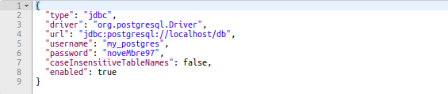
NB: we also need to download and add the jdbc driver’s jar in the directory <local drill installation folder>/3party/jars
- Query that shows the content of the postgres database from drill:
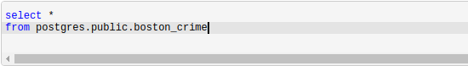
The result is shown in the picture task2_3
- The query used to display the content of the file boston crime in apache drill is the following:
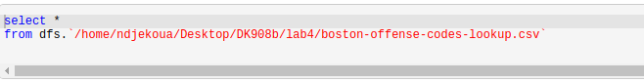
The related picture that shows the obtained result is task2_4
- To solve this query we first have to filter each table separately, then we join them together and filter out the ones that does not satisfy the join condition; the corresponding query is the following:
The picture showing the result is: task2_5.png

